Question | Scheme | Marks | AOs
1 | Using the model and the conservation of energy principle | M1 | 3.4
1 | 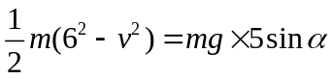 | A1 | 1.1b
1 |  | A1 | 1.1b
1 | Solve for v | M1 | 1.1b
1 | v = 4.7 or 4.69 (m s⁻¹) | A1 | 1.1b
1 |  | (5)
(5 marks)
Notes:
M1: Correct no. of terms and dimensionally correct
A1: Correct equation, condone 1 error.
A1: Correct equation
M1: Must be solving a three term equation
A1: Since g = 9.8 has been used, only these two answers

Question | Scheme | Marks | AOs
2(a) | Using the Impulse-momentum principle | M1 | 3.1b
2(a) | 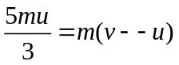 | A1 | 1.1b
2(a) | 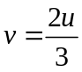 | A1 | 1.1b
2(a) | Using the model and the work-energy principle  OR: F = ma and 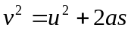 | M1 | 3.4
2(a) | 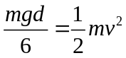 oe | A1ft | 1.1b
2(a) | Using correct strategy to solve the problem by linking the two equations and sub for v and solve for d | M1 | 3.1b
2(a) | 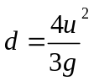 | A1 | 1.1b
2(a) |  | (7)
(b) | Make the resistance dependent on the speed | B1 | 3.5c
(b) |  | (1)
(8 marks)
Notes:
(a)
M1: Correct no. of terms, condone sign errors
A1: Correct equation
A1: Correct expression
M1: work-energy principle or F = ma and
A1ft: Correct equation but v does not need to be substituted
M1: Solve for d in terms of u and g only
A1: Any equivalent expression
(b)
B1: Appropriate comment

Question | Scheme | Marks | AOs
3(a) | Driving Force = Power / speed = 25000 / 20 = 1250 | M1 | 1.1b
3(a) | Using model to form equation of motion | M1 | 3.4
3(a) | 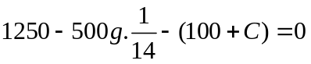 | A1 | 1.1b
3(a) | Using complete strategy to solve the problem | M1 | 3.1b
3(a) | C = 800 | A1 | 1.1b
3(a) |  | (5)
(b) | Driving Force = 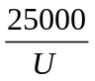 | M1 | 1.1b
(b) | Using model to form equation of motion | M1 | 3.4
 | 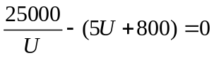 | A1 ft | 1.1b
 | 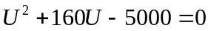 oe | A1 ft | 1.1b
 | Using complete strategy to solve the problem | M1 | 3.1b
 | U = 27 | A1 | 1.1b
 |  | (6)
(11 marks)
Notes:
(a)
M1: For attempt to find the driving force
M1: Correct number of terms with weight resolved
A1: Correct equation
M1: Solve for C
A1: 800
(b)
M1: Must find the driving force
M1: Correct number of terms
A1ft: Correct equation, follow through on their C
A1ft: Correct 3 term quadratic = 0, follow through on their C
M1: This mark can be implied by a correct answer, but otherwise must see an explicit attempt to solve.
A1: 27 (2 SF)

Question | Scheme | Marks | AOs
4(a) | Use of conservation of momentum | M1 | 2.1
4(a) | 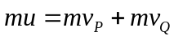 | A1 | 1.1b
4(a) | Use of NLR | M1 | 3.4
4(a) | 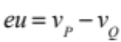 | A1 | 1.1b
4(a) | Using a correct strategy to solve the problem by setting up two equations (need both) in 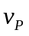and 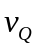and solving for 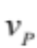 | M1 | 3.1a
4(a) | = 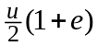 * | A1* | 2.2a
4(a) |  | (6)
(b) | 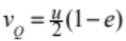 | B1 | 1.1b
 |  | (1)
(c) | KE Loss = Initial KE – Final KE | M1 | 1.1b
 | =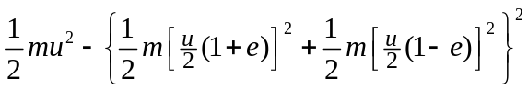 | A1 | 1.1b
 |  | A1 | 1.1b
 | Using a correct strategy to solve the problem: 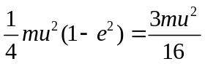  and solve for e | M1 | 3.1a
 | 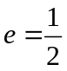 | A1 | 1.1b
 |  | (5)
(d) | After 1st impact: 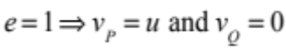 | B1 | 1.1b
(d) | After 2nd impact (P and wall): Using NLR with e =1 , 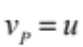 | M1 | 3.1a
(d) | Since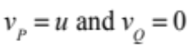, 3rd impact is a ‘repeat’ of 1st impact so 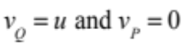 | B1 | 2.2a
(d) | Motion continues in the same way, with one particle coming to rest and the other moving with speed u | B1 | 3.2
(d) |  | (4)
(16 marks)
Question 4 notes:
(a)
M1: Correct no. of terms, condone sign errors
A1: Correct equation (allow if m has been cancelled or extra g’s)
M1: e must be on correct side of equation.
A1: Correct equation in any form
M1: Solving for
A1*: PRINTED ANSWER
(b)
B1: Any equivalent form
(c)
M1: Correct no. of terms and dimensionally correct. Allow Final KE – Initial KE
A1: Correct expression, condone 1 error
A1: Correct expression in any form
M1: Equate to 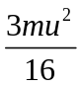 and solve for e
A1: e = 0.5
(d)
B1: Need both 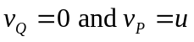
M1: Using NLR for impact with the wall to obtain 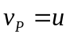
B1: Clear explanation
B1: Clear description

